Industry Growth:

<https://www.cbinsights.com/research/fashion-sustainable-technology/>

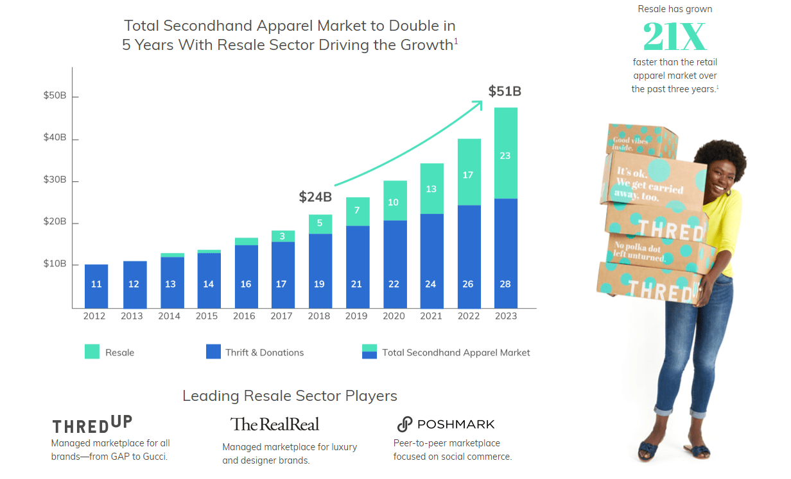

Secondhand stores are nothing new, but startups are helping these brick-and-mortar outfits find another life online — and raising significant funding. For example, [ThredUp](https://www.cbinsights.com/company/thredup), which has raised over $125M in funding, is a resale website for buying and selling secondhand clothes.

Online luxury handbag resale marketplace [Rebag](https://www.cbinsights.com/company/rebagg) recently raised a $25M Series C funding round, bringing its total funding to over $50M. [Vinted](https://www.cbinsights.com/company/vinted) follows the same model, but with the added bonus of allowing members to swap items.

[The RealReal](https://www.cbinsights.com/company/the-realreal), which will reportedly undergo [another round of funding to raise its value to $1B](https://techcrunch.com/2019/04/23/luxury-consignment-e-tailer-the-realreal-to-enter-the-unicorn-club-with-new-funding/), is a consignment shop for pre-owned luxury apparel. Designer Stella McCartney has partnered with the resale company, offering shopping credit for users consigning her items.